How use the board
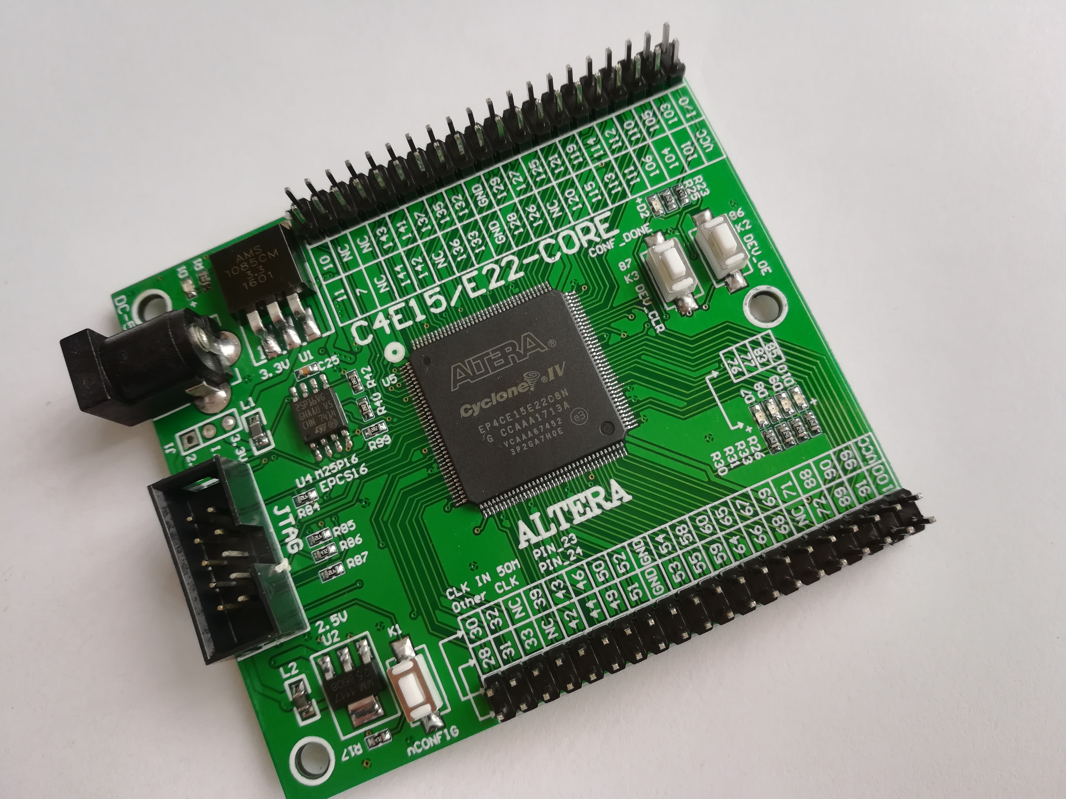
Power input DC 5V

You need use ALTERA USB Blaster or ByteBlasterII Download .SOF file to FPGA chip via JTAG , but if power loss the program will be loss . You want the program not loss, you need to download .JIC file to EPCS16(or M25P16) SPI FLASH via JTAG
K1 is a nCONFIG input FPGA pin, if you press down k1, FPGA will read program from EPCS16(ORm25p16) to FPGA. This pin is can not to programer.

K2 is a input key , you can program PIN_86 input FPGA. When you press down this key .PIN_86 is a Low level . And PIN_86 is FPGA DEV_OE(Global enable pin, but you need to program)

K3 is a input key , you can program PIN_87 input FPGA. When you press down this key .PIN_87 is a Low level . And PIN_86 is FPGA DEV_CLR(Global reset pin, but you need to program)

CLK 50M input PIN_23 , and not use one Crystal oscillator pack. Input PIN_24

EPCS16(OR M25P16) 16M bit spi flash.

4 X LED , if the led PIN is Low level ,the led will light.

All io total 73

PIN_52 PIN_53 PIN_54 PIN_55 PIN_88 PIN_89 PIN_90 PIN_91
PIN_126 PIN_127 PIN_128 PIN_129 is CLK input
Board LED ,key and CLK pin number print on board, you can see.
IO how to use
